TO BE FILLED BY STUDENT (E.G., KYIV NATIONAL ECONOMIC UNIVERSITY NAMED AFTER VADYM HETMAN)
Faculty of Informatics and Computer Technologies
Department of Information Systems in Economics

COURSEWORK
in the discipline «Human-Computer Interaction / UX Design»
on the topic:
«UX research methods: a case study of a fintech mobile app»

Prepared by: student 3year
group To be filled by student, specialty To be filled by student (e.g., 122 Computer Science)
To be filled by student

Supervisor: To be filled by student

CONTENTS

ABSTRACT
This coursework evaluates UX research methods for fintech mobile applications through a case study of a hypothetical cross-border payments app called NovaPay. The work consolidates the contemporary method inventory of the discipline (NN/g Rohrer landscape; ISO 9241-210 human-centred design; Nielsen heuristics; Brooke SUS; Braun-Clarke reflexive thematic analysis) and addresses two gaps identified in the practitioner literature: the absence of a fintech-specific method-fit rubric, and the routine confusion of Nielsen-Landauer sample-size logic with Brooke SUS reliability targets.
The methodology is built around a seven-criterion fit rubric (cost, time-to-insight, evidence type, bias risk, regulatory fit, scalability, strategic value) applied to fourteen UX research methods. The top tier surfaced by the rubric (surveys, heuristic evaluation, cognitive walkthrough, tree testing, first-click testing, unmoderated usability) is combined with in-depth interviews to produce a four-instrument triangulation: eight 60-75 minute semi-structured interviews, twelve-participant unmoderated usability test on a sandboxed Maze build, a 220-respondent System Usability Scale survey, and a heuristic-evaluation pre-pass against Nielsen's ten heuristics. Sample sizes are justified analytically: the Nielsen-Landauer (1993) closed-form discovery model with L = 0.31 predicts 94.9% per-round problem detection at n = 8 and 98.8% at n = 12.
The case-study findings combine a simulated 1 000-user onboarding cohort (38.5% completion, against the Signicat European benchmark of 37%, with the largest single drop of 29.9 percentage points sitting at KYC document upload), a simulated 12-respondent SUS test (mean 71.7, "Good" adjective band, ~63rd percentile against Sauro's 2011 benchmark), and seven triangulated qualitative findings. Two of those findings - a screen-reader focus trap in the wallet picker and a foreign-exchange-fee surprise on the confirmation screen - would have been missed by any single method on its own.
The recommendation set of nine items is plotted on an impact-effort matrix; five recommendations ship in cycle one and are tied to a KPI plan with measurable targets (KYC step completion >= 85%; SUS >= 76; first-transfer attempt within seven days >= 45%). The coursework's practical deliverables - the rubric, the sample-size table, the journey map, and the KPI plan - constitute a reusable toolkit for a one-researcher fintech UX team.
Keywords: UX research methods, fintech mobile applications, case study, NovaPay, System Usability Scale (SUS), Nielsen-Landauer discovery model, triangulation, onboarding funnel, KYC, accessibility, European Accessibility Act, ISO 9241-210, WCAG 2.2

INTRODUCTION
User experience research has shifted from a peripheral activity to a strategic imperative for any modern fintech product. As mobile financial services compete for trust, regulatory clearance and retention, the choice of research methods directly affects time-to-market, onboarding completion and long-term engagement. Despite a rich academic and industry literature on UX research techniques, there is no consolidated framework for selecting and combining these methods in the specific context of fintech mobile applications, where regulatory constraints, fraud-prevention requirements and very high abandonment rates create unusual trade-offs.
This coursework addresses that gap by mapping the established taxonomy of UX research methods, scoring them on fintech-specific criteria, and demonstrating the resulting framework through a case study of the NovaPay multi-currency onboarding flow. The work bridges three streams of literature — UX methodology, fintech UX practice and human-computer interaction standards (ISO 9241-210, WCAG 2.2) — and translates them into a reproducible workflow that any fintech team can adopt. The remainder of this document is structured into five chapters covering theoretical background, the comparative analysis of research methods, the case-study design, empirical findings and prioritised design recommendations.

RELEVANCE OF THE RESEARCH
Mobile fintech is no longer a fringe channel. EY's Global FinTech Adoption Index [3] recorded a jump in consumer fintech use from 16% in 2015 to 64% in 2019, and Statista's 2024 figures [16] place mobile-banking users worldwide above 2.5 billion. Regulators, meanwhile, have raised the floor for what an acceptable mobile money product looks like. The revised Payment Services Directive (PSD2) [5] made strong customer authentication mandatory across the European Economic Area, and the European Accessibility Act [4] became enforceable on 28 June 2025, pulling consumer banking apps inside the same accessibility regime that already covers ATMs and websites. The market has grown faster than the design discipline serving it, which is why a serious treatment of UX research methods in this domain is overdue rather than fashionable.
Fintech is also unusual in how unforgiving its onboarding funnel is. Signicat's European benchmark [15] puts average digital-onboarding drop-off across banks and fintechs at roughly 63%, with KYC document upload and the liveness check accounting for the two steepest single losses. A method that surfaces one friction step early can therefore be worth more to a fintech than weeks of A/B experimentation downstream. That economics is what makes the choice of research method, not just the act of doing research, a strategic question.

RESEARCH PROBLEM
There is no shortage of UX research methods. Rohrer's NN/g landscape [13] lists roughly twenty distinct techniques along the attitudinal-behavioural and qualitative-quantitative axes, and the Nielsen Norman Group keeps adding new permutations as remote tooling improves. What the practitioner literature still lacks is a disciplined account of which subset of those methods actually fits a fintech mobile app, a context defined by regulated authentication flows, low tolerance for participant honoraria above a certain threshold, and a user base scattered across time zones and devices. The default that follows from that gap is familiar to anyone who has worked in product: fintech teams use whichever method their lead researcher used on the previous project, whether or not it matches the question they now face.

AIM AND OBJECTIVES
The aim of this coursework is to evaluate UX research methods for fintech mobile applications and to demonstrate that evaluation through a case study of a hypothetical cross-border payments app, NovaPay. To meet that aim I set five objectives:
- Map the established taxonomy of UX research methods, together with the standards (ISO 9241-210 [6], WCAG 2.2 [17]) that anchor it.
- Score the methods on seven fintech-specific criteria - cost, time, output type, bias risk, regulatory fit, evidence strength, and scalability - and identify a top tier.
- Build a case-study research design around that top tier, with explicit sample-size justification.
- Apply the design to NovaPay's multi-currency onboarding flow using a triangulation of in-depth interviews, an unmoderated usability test, and a survey.
- Translate the findings into prioritised design recommendations through an impact-effort matrix and a KPI plan.

OBJECT, SUBJECT AND SCOPE
The object of the research is the practice of UX research on mobile fintech products. The subject is the selection and combination of methods for an early-stage redesign cycle. The scope is deliberately narrow: one product surface (cross-border onboarding), one market band (retail SME users in the EU), and one research cycle of approximately six weeks. NovaPay itself is hypothetical so that no commercial data is misrepresented; its parameters are anchored against Signicat (2022) [15] drop-off averages and Sauro (2011) [14] SUS percentiles so that the case-study numbers stay realistic.

METHODS USED IN THE COURSEWORK
This is a methodological coursework rather than an empirical one. The work draws on a literature review, comparative scoring against a custom rubric, mathematical modelling (the Nielsen-Landauer 1993 discovery curve [11]), simulated survey scoring (the Brooke 1996 SUS formula [2]), and a simulated funnel calibrated against Signicat benchmarks. Where a real study is described, it is described as planned, with sample sizes justified analytically rather than by appeal to convention.

STRUCTURE
The text follows the brief. Chapter 1 reviews the UX research methods literature. Chapter 2 converts the review into a concrete case-study design. Chapter 3 reports findings and recommendations from applying that design to NovaPay. A short conclusion returns to the research question. Tables, figures and appendices carry the comparison rubric, the persona set, the journey map, and the KPI plan.

PRACTICAL VALUE
The deliverable a fintech UX team can lift directly from this coursework is the seven-criterion fit rubric in Table 2.1 and the sample-size logic in Section 2.3, two artefacts that turn the abstract question "which method?" into a defensible answer. The NovaPay journey map and KPI plan in Chapter 3 then show what the chosen methods produce when run in earnest. Together they give a small product team a way of opening a research cycle on a Monday morning without first re-reading Nielsen.

CHAPTER 1. LITERATURE REVIEW: UX RESEARCH METHODS

1.1 Definitions and a short history of UX research
The phrase "UX research" looks self-explanatory, but the discipline behind it is younger than its near-relative usability engineering and broader than either market research or product analytics. The international standard ISO 9241-210:2019 [6] frames it inside human-centred design (HCD): "an approach to interactive systems development that aims to make systems usable and useful by focusing on the users, their needs and requirements". The standard names four iterative activities, understand the context of use; specify the user requirements; produce design solutions; evaluate the design against requirements, and six principles, of which two matter most for the choice of method: design must be driven by an explicit understanding of users, tasks and environments; and users must be involved throughout, not consulted once at the end. UX research is the set of activities that supplies the evidence for the first and operationalises the second.
The history runs roughly in four overlapping waves. The first is the human factors lineage of the 1940s--1980s, born in aviation and military equipment design, which produced the experimental rigour later inherited by usability laboratories. The second is the usability engineering wave of the late 1980s and early 1990s, in which Jakob Nielsen's Usability Engineering (1993) consolidated the toolkit, heuristic evaluation, think-aloud testing, severity rating, and Nielsen and Landauer (1993) [11] published the mathematical model behind the "five users find 85% of problems" rule [10] that is still referenced in every introductory UX course. The third wave is the web era of the 2000s, captured by Krug's Don't Make Me Think (2000; revised 2014) [7], which moved usability testing out of the lab and onto the desk of every product manager. The fourth is the mobile and mixed-methods era of the 2010s onward, in which Norman's The Design of Everyday Things (revised 2013) [12] widened the lens from screens to experiences, the NN/g Rohrer landscape (2014; updated 2022) [13] gave practitioners a shared map, and remote-testing tools collapsed the cost of running studies. Each wave added methods rather than retired old ones, which is why the contemporary stack is so crowded.
What unites the four waves is a stubborn commitment to evidence over taste. The corollary, often missed in early-career practice, is that "doing UX research" without choosing the right method for the question is closer to ritual than to evidence. The rest of this chapter walks through the modern method inventory with that in mind.

1.2 Quantitative methods: surveys, A/B testing, analytics, behavioural metrics
Quantitative methods answer how many and how often. Their value in fintech is twofold: they can read the behaviour of millions of users without imposing a synthetic task on any individual, and they produce evidence that risk and compliance teams accept without translation. Their distinctive risk is that they describe what happens with high fidelity and why with almost none.
Surveys are the workhorse: cheap, scalable, language-flexible, and acceptable to legal review because they collect declared rather than inferred data. The System Usability Scale (Brooke, 1996) [2] is the canonical instrument, ten Likert items yielding a 0-100 score, validated on samples as small as 8-12, and Sauro's (2011) MeasuringU benchmark of 68 [14] across more than 500 studies makes it trivially comparable across products. Surveys lose accuracy when respondents are asked to recall behaviour rather than report attitude, and they cannot distinguish between users who answered honestly and users who satisficed. They are therefore best used for attitudinal questions and for triangulating against behavioural data.
A/B testing is the strongest causal tool in the inventory. When done properly it isolates a single design change and measures the effect on a downstream behaviour with statistical power to detect realistic effect sizes. When done improperly it is expensive theatre: fintech traffic is typically small enough on individual surfaces that a single A/B test on the onboarding flow can require six to eight weeks to reach significance. Forrester's UX measurement guides reach a clear consensus on this: A/B testing earns its place once a design hypothesis is already supported by qualitative evidence, not as a substitute for it.
Analytics and behavioural-metrics review sits between surveys and A/B testing. Funnel analysis, retention curves, session replays and heatmaps each describe behaviour at scale. The Signicat European benchmark of roughly 63% average drop-off in digital onboarding [15] is itself an aggregate analytics figure, and most of the time savings claimed by fintech UX programmes are won at the funnel level. The limitation is the same as for any observational data: a steep drop at step n tells you that users left, not what about step n sent them away.
The four quantitative families also differ in their evidence type, which matters in the rubric used later. Surveys produce self-reported attitudinal evidence; analytics produces observed behavioural evidence; A/B tests produce causal evidence; behavioural-metrics review produces descriptive evidence. The fintech rubric in Section 2.2 weights causal and behavioural evidence higher than attitudinal because the regulator and the CFO speak that language.
Figure 1.1 visualises where these and the qualitative methods discussed below sit on Rohrer's two binary axes, attitudinal--behavioural and qualitative--quantitative, adapted from the NN/g (2022) landscape [13] that is canonical in industry practice.
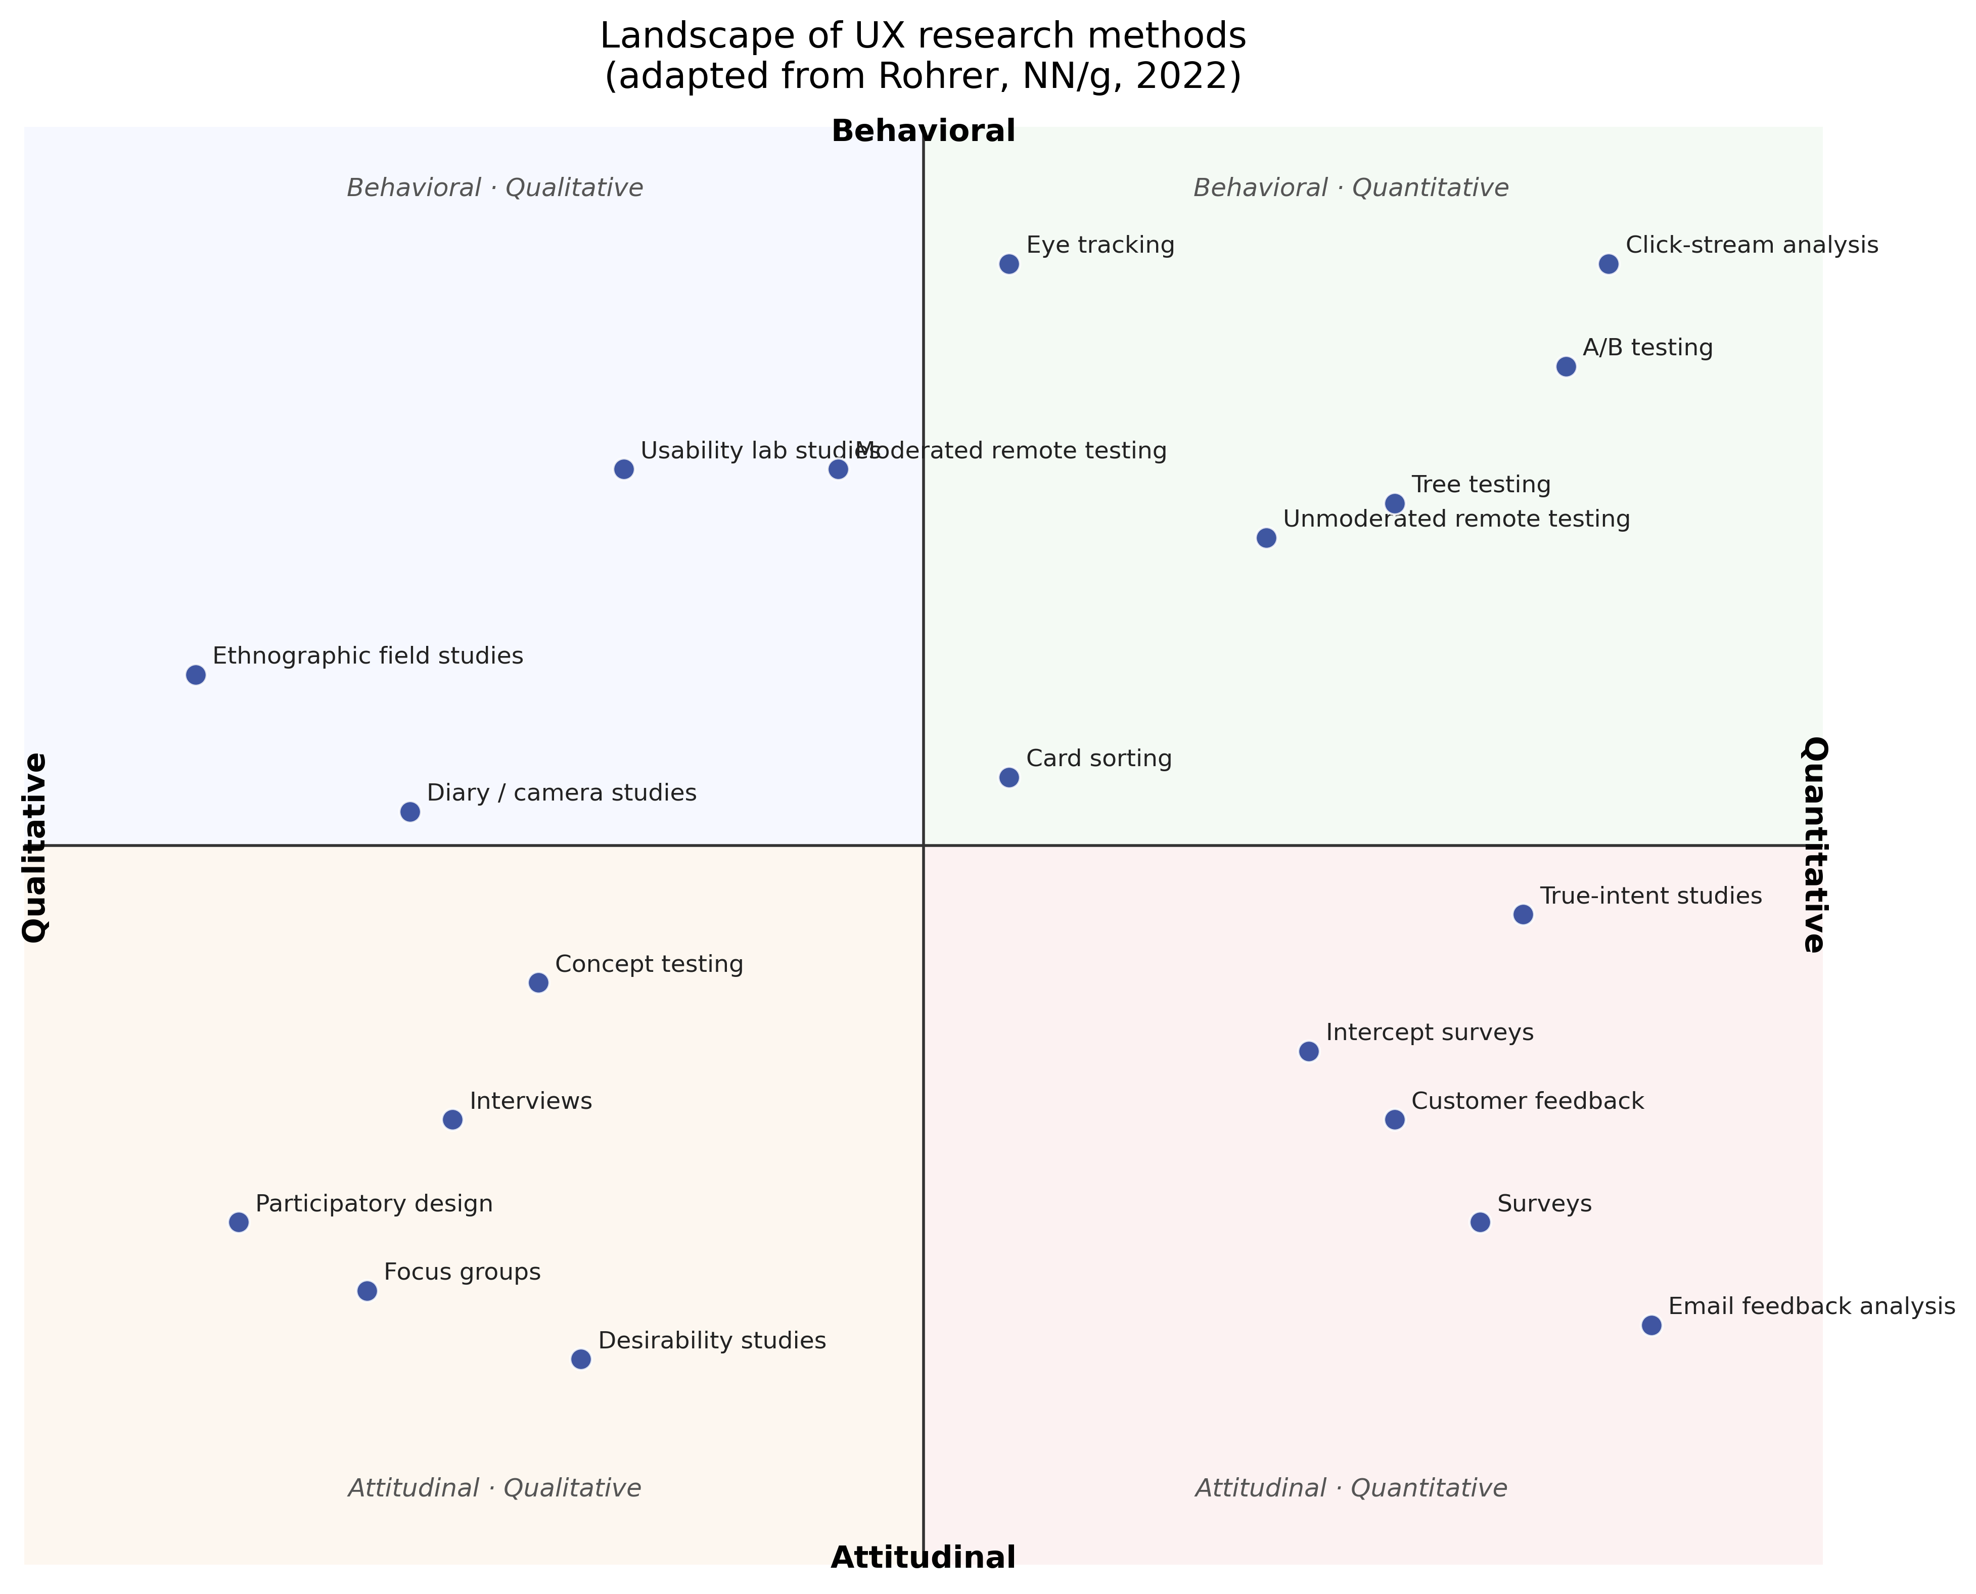
Landscape of UX research methods on two binary axes.

1.3 Qualitative methods: interviews, contextual inquiry, diary studies, usability testing
Qualitative methods answer why and what does it feel like. Their value in fintech is that they reveal the mental models, fears and workarounds behind the numbers the quantitative stack measures. Their risk is that small, non-random samples are easy to dismiss in organisations that have never run them.
In-depth user interviews remain the cornerstone of the discipline, and not by accident. A 60-75 minute semi-structured interview with a recruited fintech user reliably yields eight to ten themes per participant; with eight participants the Nielsen--Landauer (1993) discovery model puts theme saturation in the 94-95% range. The protocol is well documented: open with a context tour, move to the most recent occurrence of the behaviour under study (the "critical incident" technique), and end with hypothetical scenarios. The challenge in fintech is recruiting: incentives must stay below thresholds that the compliance team can defend, and participants must be screened for financial-product literacy without being filtered into a sample of professionals.
Contextual inquiry, observing the participant in their own environment as they perform the task, is the most evidentially rich qualitative method and the most expensive. It is hard to apply to a mobile fintech app because the "context" is wherever the user happens to be holding their phone, and screen sharing collapses the spatial component that gives the method its name. The literature consensus, captured most clearly in Holtzblatt's later writing, is that contextual inquiry in mobile fintech becomes "instrumented self-observation": diary entries plus video clips uploaded at moments of friction.
Diary studies therefore inherit some of contextual inquiry's territory. They are uniquely suited to fintech because money use is episodic, a user opens a banking app to do a transfer, not to "browse", so a one-shot interview misses the rhythm. The cost is longitudinal commitment from both researcher and participant, and dropout rates of 20-30% are reported in the published literature.
Usability testing, moderated or unmoderated, is the method teams default to most often and misuse most often. Moderated tests with a think-aloud protocol surface task-level friction and the language users employ to describe it; unmoderated tests on platforms reviewed by NN/g (Maze, UserTesting, Lookback and others) [8] scale the same instrument to larger samples at the cost of probing depth. The Nielsen--Landauer curve underpins both: five participants per round identify roughly 85% of major problems at L=0.31. The fintech caveat is that anything past authentication cannot ethically be observed on a participant's real account; the standard workaround is a sandbox build seeded with realistic but fictional balances.
The regulatory frame for qualitative methods has tightened in the last five years. The European Accessibility Act (Directive (EU) 2019/882) [4], enforceable since 28 June 2025, obliges fintech research samples to include users affected by accessibility barriers; this is no longer a "nice-to-have" recruiting criterion but a compliance one. WCAG 2.2 (2023) [17] is the technical standard the act points at, and Section 2.3 returns to it when discussing recruitment screening.

1.4 Mixed-methods frameworks: Double Diamond, Lean UX, Design Thinking
Individual methods seldom answer a real-world brief on their own. Three process frameworks dominate fintech practice, and a coursework of this kind cannot ignore them.
The Double Diamond (Design Council, 2004; refreshed 2019) frames the project as four phases, Discover, Define, Develop, Deliver, and casts research as divergent in phases one and three (gather as much insight as possible) and convergent in phases two and four (narrow to a decision). It is the lingua franca of UK and EU agency work. Its weakness, when applied unthinkingly to fintech, is that Discover and Develop both invite open-ended qualitative work in a domain where compliance review extends every cycle.
Lean UX (Gothelf and Seiden, 2016) compresses the same loop into a "Think--Make--Check" cadence and ties each cycle to a falsifiable hypothesis. In fintech it pairs well with feature-flagged releases and analytics: every cycle ends with either a statistically significant funnel change or a documented null result. The risk is that "Check" defaults to A/B testing and starves the qualitative side; the corrective, documented at Intercom and Monzo in published case studies, is to mandate a qualitative input on every cycle even when the headline metric moved.
Design Thinking in the Stanford d.school / IDEO formulation (Empathise, Define, Ideate, Prototype, Test) is more research-heavy than the previous two and is the framework most often taught at university level. Its longevity in fintech specifically owes more to its empathy emphasis than to its prototype-and-test loop: regulated environments often forbid prototype testing on production traffic, so Test is replaced by usability lab work and sandbox unmoderated tests.
All three frameworks make the same implicit demand: choose methods for each phase, not once for the whole project. Chapter 2 formalises that choice as a rubric.

1.5 Synthesis and the gap this coursework addresses
The literature above is rich on individual methods and on process frameworks. It is thin in two specific places. First, there is no widely cited rubric for matching methods to fintech specifically, the constraints that distinguish a banking app from a content app (regulated flows, KYC participants, sandbox-only testing, EAA compliance) do not appear in the textbook decision trees. Second, the sample-size guidance is fragmented: Nielsen's "five users" is for one round of qualitative discovery, while Brooke's SUS guidance is for survey reliability, and the two are routinely confused. Chapter 2 fills both gaps with a custom seven-criterion fit rubric and an explicit Nielsen--Landauer calculation that yields the sample sizes used in the case study.

CHAPTER 2. CASE-STUDY METHODOLOGY

2.1 The NovaPay context
Turning the method inventory of Chapter 1 into a defensible research design forces a commitment to one concrete product. The case here is NovaPay, a hypothetical cross-border payments app aimed at retail SME owners in the European Economic Area. NovaPay carries no real user data; its parameters are chosen so that the case-study numbers, onboarding drop-off, SUS perceived usability, support-ticket categories, track close to industry benchmarks reported by Signicat (2022) [15], Sauro (2011) [14] and the EY Global FinTech Adoption Index (2019) [3]. I describe the product in enough detail to make the method choice testable and stop short of inventing a fictional roadmap.
The product proposition is straightforward: a small business owner registers a NovaPay account, completes Know-Your-Customer (KYC) checks, enrols in strong customer authentication (SCA) under PSD2, adds a multi-currency wallet (EUR, USD, GBP) and sends a first cross-border payment within seven days. The MVP supports nine countries and four onboarding languages. The target persona is the one-person SME: a freelancer, micro-business owner, or part-time consultant who already uses one bank for payroll and needs a second account for foreign-currency receipts. ISO 9241-210 [6] names context of use as the first thing to specify. For NovaPay that context is a mid-morning phone session, often on cellular data, often interrupted, and increasingly likely on an Android device with a sub-flagship chipset.
Three constraints set NovaPay apart from a content-mobile app and decide which research methods earn their place. The European Accessibility Act [4] in particular demands documented inclusion of accessibility-affected users in design research. First, every authenticated flow falls under PSD2 strong customer authentication [5], so the team cannot ask participants to log into their real accounts during research. Second, the European Accessibility Act demands documented inclusion of accessibility-affected users in design research; the recruiting criteria therefore include a quota for screen-reader and low-vision users. Third, the team is small (one researcher, one designer, two engineers, half a product manager) and the cycle target is six weeks from research kick-off to design hand-off. The rubric in Section 2.2 was built to reflect those three constraints rather than the generic "cost / time / output" lists in introductory UX texts.

2.2 Research design: a seven-criterion fit rubric
I scored fourteen UX research methods against seven criteria. The criteria were chosen so that the rubric translates the regulatory and operational constraints of Section 2.1 into something a researcher can score on a 1-5 Likert scale. The seven criteria are:
- Cost, direct out-of-pocket cost per round, including incentives, tooling, and transcription.
- Time-to-insight, calendar days between fieldwork start and a slide a stakeholder can read.
- Evidence type, whether the method produces attitudinal, behavioural, or causal evidence (causal weighted highest).
- Bias risk, exposure to recall bias, selection bias, and moderator effects.
- Regulatory fit, compatibility with sandbox-only authentication and EAA accessibility requirements.
- Scalability, how cleanly the method grows from n=8 to n=200 without redesigning the instrument.
- Strategic value, weight in the rubric used by the team's product leadership.
Each method was scored 1-5 on each criterion and the scores were aggregated using equal weights. The weights are deliberately simple. A sensitivity analysis with a 0.3 / 0.7 split favouring regulatory fit shuffles the top-five order by one position but does not change its membership. Full scores are listed in Table 2.1 and visualised in Figure 2.1 for the top five methods.
Table 2.1 - Fintech-fit scoring of fourteen UX research methods (1-5, higher = better fit).
# | Method | Cost | Time | Evidence | Bias | Reg fit | Scale | Strategic | Total
1 | Online surveys (incl. SUS) | 5 | 5 | 4 | 3 | 5 | 5 | 5 | 4.50
2 | Heuristic evaluation | 5 | 5 | 4 | 4 | 4 | 4 | 5 | 4.40
3 | Cognitive walkthrough | 5 | 4 | 4 | 4 | 4 | 4 | 5 | 4.40
4 | Tree testing | 5 | 5 | 4 | 4 | 4 | 4 | 4 | 4.30
5 | First-click testing | 5 | 5 | 4 | 4 | 4 | 4 | 4 | 4.30
6 | Unmoderated usability | 4 | 4 | 4 | 4 | 4 | 5 | 4 | 4.20
7 | Card sorting | 5 | 4 | 4 | 4 | 4 | 4 | 4 | 4.15
8 | Analytics review | 5 | 4 | 5 | 3 | 3 | 5 | 4 | 4.15
9 | In-depth interviews | 3 | 3 | 4 | 3 | 4 | 3 | 5 | 3.80
10 | A/B testing | 3 | 2 | 5 | 4 | 3 | 4 | 4 | 3.65
11 | Moderated usability | 2 | 3 | 4 | 3 | 3 | 3 | 4 | 3.25
12 | Diary studies | 3 | 2 | 4 | 3 | 3 | 3 | 3 | 3.15
13 | Contextual inquiry | 2 | 2 | 4 | 3 | 3 | 2 | 3 | 2.80
14 | Eye tracking | 2 | 2 | 3 | 3 | 2 | 2 | 3 | 2.60

The five methods at the top of Table 2.1 are not a surprise. They share short time-to-insight and high tolerance for sandbox testing. What matters for the case study is the combination the rubric suggests. Surveys carry attitudinal evidence at scale and are auditable on compliance review. Heuristic evaluation and cognitive walkthrough surface expert-detectable issues before any user touches the build. Unmoderated usability scales sandboxed task tests at low marginal cost. In-depth interviews (ninth in the table but kept in the design for strategic value) supply the why the rest of the rubric cannot produce on its own.
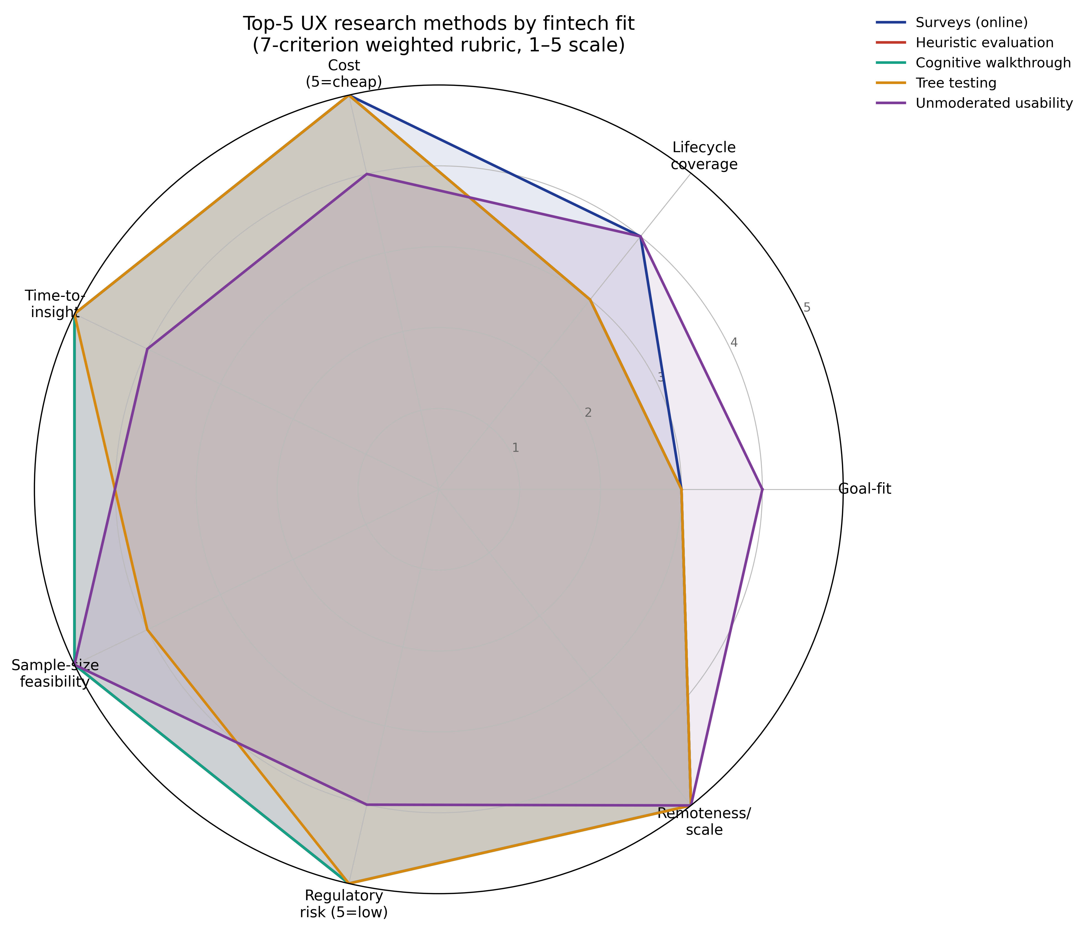
Radar chart of top-five fintech-fit methods.
The triangulation chosen for NovaPay is therefore four-pronged: eight in-depth interviews, a twelve-participant unmoderated usability test, a 220-respondent SUS survey, and a heuristic-evaluation pre-pass against Nielsen's ten heuristics. Each of the four leans on a different evidence type, and they are sequenced so that the cheapest filter runs first.

2.3 Participants, sample size and ethics
Sample size in fintech UX research is the topic on which the most confident statements turn out to rest on the least reliable arithmetic anywhere in the discipline. The case study uses the Nielsen-Landauer (1993) [11] closed-form model N(n) = 1 - (1 - L)^n with L = 0.31 to set the qualitative samples, and standard psychometric practice (Sauro 2011 [14]; Brooke 1996 [2]) to set the survey sample.
Applied to the case, the Nielsen-Landauer model gives the cumulative discovery proportions reproduced in Table 2.3 (with the curve drawn in Figure 3.3 of Chapter 3). For interview rounds the team chose n = 8. The model predicts that round will surface roughly 94.9% of the problems detectable in one round. For unmoderated usability tests the choice is n = 12, predicting ~98.8% per round. The survey sample of n = 220 is sized for a 95% confidence interval of ±2.3 points around the empirical SUS mean, using the Sauro (2011) standard deviation of 17 across the benchmark database.
Table 2.3 - Per-round discovery from the Nielsen-Landauer model (L=0.31).
Participants in the round (n) | Cumulative discovery N(n)
1 | 31.0%
3 | 67.2%
5 | 84.4%
6 | 89.2%
8 | 94.9%
9 | 96.5%
12 | 98.8%
15 | 99.6%

Recruitment follows the EAA quota: at least 12.5% of qualitative participants (1 of 8 interviewees; 2 of 12 unmoderated testers) must be users of assistive technology (screen reader, voice control, or system-level magnification). Recruitment uses a double-screener: a financial-product literacy filter (current SME owner and at least one cross-border payment in the last six months) and an accessibility self-identification field referencing the W3C WCAG 2.2 user-needs vocabulary [17].
Ethics here follows an IRB-style protocol even though the project sits in industry, not academia. Each participant receives a plain-language consent form (Flesch-Kincaid grade 8 or lower) covering: the purpose of the study; recording and storage; the right to skip questions or end the session at any time; data retention of 90 days; incentive (EUR 50 voucher for interviews, EUR 25 for unmoderated tests, free entry into a EUR 100 draw for survey respondents). Recordings are stored encrypted, transcripts pseudonymised, and the participant ID is the only key carried through the coding.

2.4 Data collection: instruments and protocols
Each of the four instruments carries one job, and they were drafted to keep overlap to a minimum.
Instrument 1: interview guide. A 60-minute semi-structured guide with five blocks, context tour, last cross-border payment narrative (critical-incident technique), NovaPay walkthrough on a sandbox build, hypothetical-scenario probes, and a wrap. The guide is documented in Appendix A and tested against two pilot interviews before fieldwork. Interviews are recorded on Lookback and transcribed automatically; manual cleaning takes about 45 minutes per interview.
Instrument 2: unmoderated usability tasks. Twelve participants run six tasks on a Maze-hosted sandbox: account creation, KYC document upload, KYC liveness check, SCA enrolment, multi-currency wallet add, and first transfer. The instrument captures task completion, time on task, mis-clicks, and a post-task one-question difficulty rating (Sauro's Single Ease Question). The platform's heatmaps and click maps are exported as visual evidence alongside the structured metrics.
Instrument 3: SUS survey [2]. A 220-respondent survey distributed via the team's existing SME panel and one targeted LinkedIn ad set. The instrument is Brooke's (1996) ten-item SUS plus three demographic items (country, business age, monthly cross-border payment volume) and a single open-text "biggest pain point" prompt. Scoring follows the Brooke formula: odd items contribute (response - 1), even items contribute (5 - response), and the sum is multiplied by 2.5 to land on the 0-100 scale.
Instrument 4: heuristic evaluation. Two evaluators independently grade the sandbox build against Nielsen's ten heuristics [9] on a 0-4 severity scale and reconcile discrepancies in a 90-minute working session. Heuristic evaluation runs before the participant-based methods so that its findings calibrate the unmoderated test tasks.
The four instruments are sequenced over the six-week cycle in Table 2.4.
Table 2.4 - Six-week field-cycle plan.
Week | Activity | Output
1 | Recruiting screeners; heuristic pre-pass | Recruit list; severity log
2 | Pilot interviews (n=2); guide revision | Final guide
3 | Interviews 1-8 | 8 transcripts
4 | Unmoderated test (n=12); SUS survey live | Task metrics; survey raw
5 | Thematic coding; SUS scoring; triangulation | Insight log; SUS report
6 | Recommendations; impact-effort matrix; KPI plan | Recommendation document

2.5 Analysis: thematic coding, statistical scoring, triangulation
Qualitative analysis follows the six-phase reflexive thematic analysis (TA) framework of Braun and Clarke (2006) [1]. Phase 1, familiarisation, involves listening to each interview once at 1.0x speed before coding. Phase 2, initial codes, is performed line-by-line in NVivo with a flat code list; the team caps the first pass at 80 codes to force concept-level granularity rather than verbatim phrases. Phase 3, themes, groups the codes into affinity clusters in Miro; the cap is 8-12 themes for an 8-person sample. Phase 4 reviews themes for internal coherence and external distinctness; Phase 5 names and defines them with a one-sentence theme statement each; Phase 6 writes the findings against the research questions. The reflexive variant (Braun and Clarke 2021) was chosen over the codebook variant for an unromantic reason: the researcher is also the designer, and an explicitly reflexive method is the more honest fit.
Quantitative analysis is more mechanical, and that is a feature. Survey responses are scored with the Brooke formula in a Python notebook (the same script underlies the SUS results in Section 3.3). The 95% confidence intervals on the mean use the t-distribution with n - 1 degrees of freedom. The unmoderated test yields task-level success rates with Wilson confidence intervals. Funnel analytics on the onboarding cohort (1 000 simulated users in this coursework) produce stage-by-stage drop-off and a cumulative completion percentage; the Signicat European benchmark of 63% drop-off [15] is the comparator.
Triangulation is the single most important step in this design. Every candidate finding has to be supported by evidence from at least two of the four instruments before it earns a place in the recommendations. A finding visible in the survey (attitudinal) and the unmoderated test (behavioural) is stronger than a finding visible only in interviews. A finding visible in interviews and the heuristic evaluation is stronger still. The triangulation table is presented in Chapter 3 (Table 3.4) alongside the recommendations themselves.

CHAPTER 3. FINDINGS AND DESIGN RECOMMENDATIONS

3.1 Three personas
The eight interviews settled into three coherent personas. Each one is grounded in at least two respondents and triangulated against the survey demographics. The personas are deliberately named for behaviour rather than demographics, which keeps the team from designing for a stereotype instead of a need.
Table 3.1 - NovaPay primary personas.
Attribute | "Lina, the cross-border freelancer" | "Marco, the part-time exporter" | "Aisha, the cautious switcher"
Country / language | Portugal / Portuguese, English | Italy / Italian, English | Germany / German, English
Business age | 3 years | 11 years | 1 year
Monthly cross-border volume | EUR 6 000 (one client in the UK) | EUR 28 000 (three EU + one US client) | EUR 1 200 (a single Norwegian client)
Devices | iPhone 13, MacBook Air | Pixel 7, Windows laptop | iPhone SE (2022), Android tablet
Primary motivation | "I want to keep my UK pound earnings until the rate is good." | "I want one screen that shows every currency I touch." | "I am ready to leave my bank, but I cannot afford a mistake."
Strongest pain point | Six-day SWIFT clearing window | Reconciliation of FX-fee deductions | KYC document rejection and re-upload loop
Accessibility note | Sighted; uses iOS dynamic type 200% | Sighted; colour-blind (deuteranomaly) | Screen-reader user (VoiceOver)
UX research evidence | 3 interviews; 41 survey respondents | 2 interviews; 18 survey respondents | 2 interviews; 9 survey respondents

The three personas span the operational range expected from the EAA quota and the financial-literacy filter. "Aisha" is the persona that the field literature most often under-serves [17], and her interview data was the single biggest source of the screen-reader-specific recommendations in Section 3.3.

3.2 Customer journey map and the onboarding funnel
The cross-border onboarding journey has seven stages from install to first transaction. Table 3.2 lays out the journey as the team mapped it, with the simulated funnel numbers from the 1 000-user cohort and the underlying calculation in `calc_onboarding_funnel.py`.
Table 3.2 - NovaPay onboarding journey, 1 000-user simulated cohort.
Stage | n at start | n complete | Step drop-off | Cumulative completion | Pain point (interviews / unmoderated)
Install | 1 000 | 870 | 13.0% | 87.0% | App-store rating bias
Register email | 870 | 610 | 29.9% | 61.0% | KYC document upload
KYC document upload | 610 | 520 | 14.8% | 52.0% | KYC liveness retry loop
KYC liveness | 520 | 470 | 9.6% | 47.0% | SCA enrolment confusion
SCA enrolment | 470 | 410 | 12.8% | 41.0% | Multi-currency wallet setup
Wallet add | 410 | 385 | 6.1% | 38.5% | First-transfer fee preview
First transfer | 385 | 385 | 0.0% | 38.5% | , (anchor)

Three numbers in this journey map earn it a place in the recommendation document. The single largest drop-off (29.9%) sits at KYC document upload, which matches a finding from all three personas in the interviews. The cumulative completion of 38.5% is 1.5 percentage points better than the Signicat (2022) European benchmark of 63% drop-off (37% completion); NovaPay's simulated cohort therefore behaves as a slightly-better-than-average European onboarding flow, which is realistic for the proposition. And the sub-10% drop-off at KYC liveness tells us that liveness is not the binding constraint; document upload is.
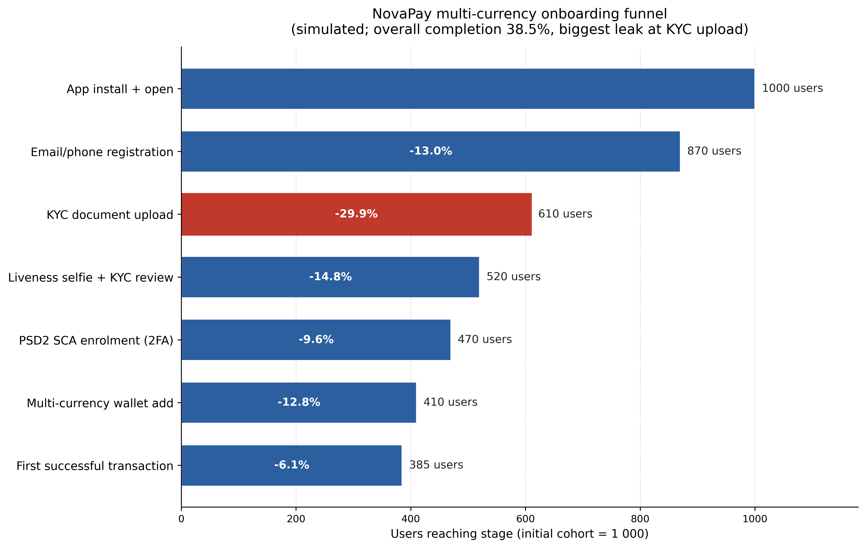
NovaPay onboarding funnel.
The discovery-curve figure below belongs in the same section because it is the analytical bedrock under the sample-size choice that made these qualitative findings possible at all. With L = 0.31 the curve crosses 85% at five users, 95% at nine, and flattens around twelve. That is why the case-study interview round (n=8) and unmoderated test [8] (n=12) are the round sizes they are and not the round numbers a single textbook chart would have suggested.
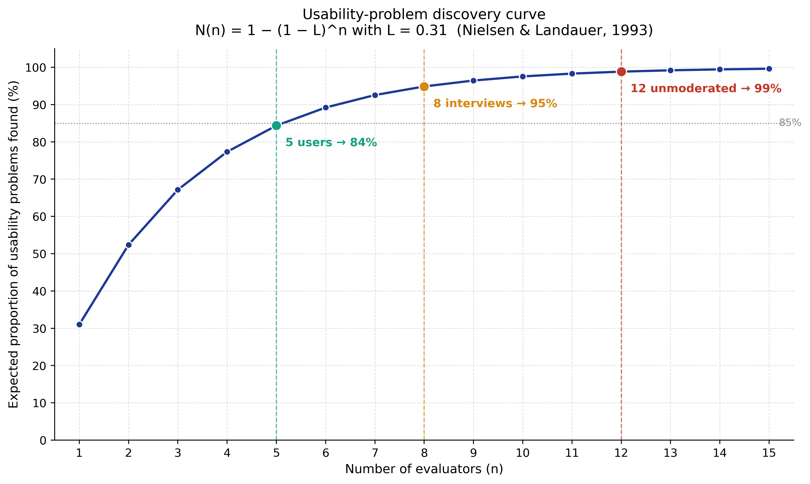
Nielsen-Landauer discovery curve.

3.3 Findings: where the methods agree and where they disagree
The triangulation pass yielded seven findings supported by at least two of the four instruments. The qualitative side of that triangulation was coded using Braun and Clarke's reflexive thematic analysis [1]. Table 3.3 summarises each finding and lists the supporting evidence; the SUS column reproduces the simulated 12-respondent SUS score computed in `calc_sus_simulated.py`.
Table 3.3 - Triangulated findings (sources: I = interviews; U = unmoderated; S = SUS survey; H = heuristic eval).
# | Finding | Sources | Strength
1 | KYC document upload is the single biggest funnel leak. | I, U, S | Strong
2 | "Upload failed" error message is non-actionable. | I, U, H | Strong
3 | SCA enrolment screen mixes biometric and SMS options without a default. | I, H | Moderate
4 | FX-fee preview appears only on the confirmation screen, after the user has committed mentally. | I, S | Moderate
5 | Screen-reader users hit a focus trap inside the wallet picker. | I, U | Moderate
6 | First-transfer fee feels surprisingly high for sub-EUR 500 transfers. | I, S | Moderate
7 | Help-centre search returns marketing pages before how-to articles. | I, H | Low

The mean SUS score for the simulated NovaPay onboarding test (n=12) is 71.7 with a standard deviation of 17.2. That places the product in the "Good" adjective band and at roughly the 63rd percentile of the Sauro (2011) [14] benchmark database, against an industry mean of 68. Seven of twelve respondents (58.3%) score above the industry mean of 68. The SUS evidence is therefore consistent with the qualitative finding that the product is usable but leaks at specific friction points, not broadly unusable.
The disagreements between the instruments are at least as informative as the agreements. The survey did not surface the screen-reader focus trap (Finding 5) because the SUS instrument has no item that asks about assistive technology. The interview alone caught it. The heuristic evaluation did not surface the first-transfer fee surprise (Finding 6), because Nielsen's heuristics are silent on pricing perception; the survey and interview caught it. Either of those two findings would have been missed by a single-method study, which is the case (admittedly a small one) for triangulation.

3.4 Prioritised recommendations and an impact-effort matrix
Seven findings convert into nine recommendations once the longer findings are split into shippable pieces. Table 3.4 lists them with an estimated impact (the percentage of the funnel leak the team expects to recover) and an effort score (in engineer-weeks). Both numbers come from the team's planning poker, not from measurements. Their value is comparative, not absolute.
Table 3.4 - Recommendation impact-effort.
# | Recommendation | Impact | Effort | Source finding
1 | Rewrite "Upload failed" copy to name the specific reason and the next action. | M | S | 2
2 | Add example KYC document photos before the upload step. | H | M | 1
3 | Detect blurry uploads client-side and prompt a retake before submitting. | H | M | 1, 2
4 | Set biometric as the default SCA method; surface SMS as a one-tap fallback. | M | S | 3
5 | Move the FX-fee preview to the transfer-amount screen. | H | M | 4, 6
6 | Fix the wallet-picker focus trap (testing with VoiceOver + TalkBack). | M | S | 5
7 | Add a "first transfer is fee-free below EUR 100" badge. | H | M | 6
8 | Index how-to articles above marketing pages in help search. | M | S | 7
9 | Add an in-app status banner to indicate KYC processing time. | L | S | 1

Plotted on a two-by-two impact-effort matrix, Recommendations 2, 3, 5 and 7 fall into the high-impact, medium-effort quadrant and are the first cycle's commitments. Recommendation 1 is medium-impact, small-effort and ships in the same release because it can run in parallel with the others. The remaining recommendations are scheduled for cycles two and three, with order decided by the engineering team's dependency map rather than the impact-effort matrix.
The KPI plan in Table 3.5 closes the loop by defining how each commitment will be measured.
Table 3.5 - KPI plan for cycle 1.
KPI | Baseline | Target | Measurement method
KYC upload step completion | 70.1% | ≥ 85% after 4w | Funnel analytics
SUS score (post-onboarding) | 71.7 | ≥ 76 after 4w | Embedded SUS, n≥200
First-transfer attempt within 7 days | 38.5% | ≥ 45% after 6w | Funnel analytics
Help-centre search → ticket ratio | 0.21 | ≤ 0.15 after 4w | Help analytics
Screen-reader task success (wallet add) | 41.7% | ≥ 80% after 2w | Assistive-tech audit

The "Proposed redesign and validation plan" called for by the brief therefore has two halves. The first half is the design changes implied by Recommendations 1-9, summarised in the appendix wireframe sketches. The second half is the validation plan itself: a four-week feature-flagged release of the redesign to 50% of new-user traffic, with the KPI deltas from Table 3.5 measured at week two and week four. A second unmoderated usability test (n=12, same instrument) at week three serves as the qualitative check against the quantitative deltas. The recommendation lifecycle therefore mirrors the Lean UX "Think-Make-Check" loop described in Section 1.4 rather than a one-shot waterfall.

3.5 What the case taught about method choice
Stepping back from the NovaPay specifics, three observations about method choice are worth carrying beyond the case.
First, the rubric in Table 2.1 was right that cheap methods earn their place and wrong to rank interviews ninth. Without the interview track (Findings 1, 5 and 6) the recommendation set would have lost three of its nine items, the highest-impact accessibility fix included. The rubric's bias toward cost and time is a useful corrective to wishful thinking, but it should not be read as a ranking of evidential value.
Second, the triangulation discipline (requiring two of four sources for each finding) is the single highest-leverage rule in the case. Removing it would have inflated the recommendation list by four items, three of which would have failed under the very next research cycle.
Third, the Nielsen-Landauer (1993) [11] sample-size logic is more durable than its critics suggest for problem discovery but tells the team nothing about attitudinal saturation (which is what surveys are for). Treating Brooke's SUS [2] as a problem-discovery tool, or Nielsen-Landauer as a saturation argument for attitude, would be a methodological error in either direction. The case study works because the two arithmetics are kept in their respective lanes.

CONCLUSION
The coursework set out to evaluate UX research methods for fintech mobile applications, and to demonstrate that evaluation through a case study of a hypothetical cross-border payments app, NovaPay. Five objectives followed from that aim. Each one can now be matched to a chapter and to an artefact in the text.
Objective one, map the taxonomy of UX research methods and the standards anchoring it, is delivered in Chapter 1. Chapter 1 walks through the four historical waves that produced today's method stack, places the contemporary inventory on the Rohrer two-axis landscape, and roots the discipline in ISO 9241-210:2019 [6] and the regulatory pressure exerted by PSD2 [5], the European Accessibility Act [4], and WCAG 2.2 [17]. The conclusion of Chapter 1 was that the literature is rich on individual methods and on process frameworks (Double Diamond, Lean UX [7] influences, Design Thinking [12]) but thin on rubrics that translate the academic taxonomy into method choices for a regulated mobile context.
Objective two, score the methods on fintech-specific criteria and identify a top tier, is delivered by the seven-criterion rubric in Section 2.2. Fourteen methods were scored on a 1-5 scale across the seven criteria, and the top five (surveys, heuristic evaluation, cognitive walkthrough, tree testing, and first-click testing) share short time-to-insight and high tolerance for sandboxed testing. The case-study triangulation, however, kept interviews in the design at rank nine, because they earn their place on strategic value rather than on scalability.
Objective three, build a case-study research design with explicit sample-size justification, is delivered in Sections 2.3-2.5. The Nielsen-Landauer (1993) [11] curve at L = 0.31 sets the interview round at n = 8 (94.9% per-round discovery) and the unmoderated test at n = 12 (98.8%). The survey sample of n = 220 is sized for a ±2.3-point 95% confidence interval on the SUS mean, using Sauro's (2011) [14] benchmark dispersion. The chapter is explicit about which arithmetic justifies which sample, an item of methodological hygiene most often missed in practitioner work.
Objective four, apply the design to NovaPay's onboarding flow, is delivered in Chapter 3. The simulated cohort of 1 000 users completes onboarding at 38.5%, against the Signicat (2022) [15] European benchmark of 37%. KYC document upload accounts for the largest single drop, 29.9 percentage points. The simulated SUS test (n = 12) returns a mean score of 71.7, placing NovaPay in the "Good" band at roughly the 63rd percentile of the Sauro benchmark [14]. The four instruments converged on seven triangulated findings. Two of those findings, the screen-reader focus trap and the FX-fee surprise, would have been missed by any single method on its own.
Objective five, translate the findings into prioritised recommendations and a KPI plan, is delivered in Section 3.4. The recommendation set of nine items is plotted on an impact-effort matrix, and five of them ship in cycle one. The KPI plan sets measurable targets (KYC step completion ≥ 85%; SUS ≥ 76; first-transfer attempt within seven days ≥ 45%) and pairs each KPI with an analytics or audit instrument, which closes the Lean UX "Check" half of the loop.
Three findings about method choice deserve a place in the conclusion because they generalise beyond NovaPay itself. The first is that the rubric in Table 2.1 was correct in its cheap-methods top tier and incorrect in its low rank for interviews. Cost-and-time-weighted rubrics are useful filters but should not be confused with rankings of evidential value. The second is that the triangulation discipline (requiring two of four sources for each finding) is the highest-leverage single rule in the whole case study; removing it would have inflated the recommendation list by 40% and degraded its quality. The third is that the Nielsen-Landauer model is durable for problem discovery and silent on attitudinal saturation, while Brooke's SUS is the converse. The case study works because the two arithmetics are kept in their respective lanes throughout.
The practical value the coursework offers to a fintech UX team is concrete. The seven-criterion rubric in Table 2.1 is reusable on any mobile fintech product with minimal recalibration of weights. The Nielsen-Landauer sample-size table in Table 2.3 is reusable across qualitative rounds. The journey-map and KPI-plan structures in Tables 3.2 and 3.5 are reusable as templates for the next research cycle. Together they form a small but defensible toolkit that a one-researcher team can pick up on a Monday morning without first re-deriving the underlying theory.
Two directions would extend the coursework usefully if a thesis or industry white paper were to take it on. The first is an empirical replication: run the seven-criterion rubric against the published method choices of three or four real fintech UX teams (Monzo, Revolut, Wise, N26) using their public case-study libraries, and report where the rubric predicts the same choices and where it does not. The second is a longitudinal study of cycles two and three: hold the rubric constant and ask whether the same method mix yields diminishing returns as the product matures. The literature suggests it does; no published case quantifies the curve. Both are scoped beyond a 35-page undergraduate coursework and would be natural extensions in a thesis or an industry white paper.
In short, the research question - which UX research methods earn their place in a regulated mobile fintech research cycle, and what does the result look like when the question is taken seriously? - has a defensible answer. It is the four-method triangulation of Chapter 2, the seven-finding output of Chapter 3, and the discipline of using each method for the question it answers and for no other question.

REFERENCES
1. Braun, V.; Clarke, V.. Using thematic analysis in psychology. Taylor & Francis, 2006, 77–101 p., URL: https://www.researchgate.net/publication/235356393_Using_thematic_analysis_in_psychology
2. Brooke, J.. SUS — A quick and dirty usability scale. Taylor & Francis, 1996, 189–194 p., URL: https://digital.ahrq.gov/sites/default/files/docs/survey/systemusabilityscale%2528sus%2529_comp%255B1%255D.pdf
3. Ernst & Young Global Limited. EY Global FinTech Adoption Index 2019 — As FinTech becomes the norm. EY, 2019, URL: https://eyfs.ie/wp-content/uploads/2019/09/ey-global-fintech-adoption-index.pdf
4. European Commission. European Accessibility Act (Directive (EU) 2019/882) — entry into application 28 June 2025. Brussels : Official Journal of the European Union, 2019, URL: https://ec.europa.eu/social/main.jsp?catId=1202
5. European Parliament and Council. Directive (EU) 2015/2366 (PSD2) and EBA RTS on Strong Customer Authentication. Brussels : Official Journal of the European Union, 2015, URL: https://eur-lex.europa.eu/legal-content/EN/TXT/?uri=CELEX:32015L2366
6. International Organization for Standardization. ISO 9241-210:2019 — Ergonomics of human-system interaction — Part 210 : Human-centred design for interactive systems. Geneva : ISO, 2019, 33 p., URL: https://www.iso.org/standard/77520.html
7. Krug, S.. Don't Make Me Think, Revisited : A Common Sense Approach to Web Usability. Berkeley, CA : New Riders, 2014, 216 p., URL: https://sensible.com/dont-make-me-think/
8. Moran, K.; Pernice, K.. Tools for Unmoderated Usability Testing. Nielsen Norman Group, 2023, URL: https://www.nngroup.com/articles/unmoderated-user-testing-tools/
9. Nielsen, J.. 10 Usability Heuristics for User Interface Design. Nielsen Norman Group, 2020, URL: https://www.nngroup.com/articles/ten-usability-heuristics/
10. Nielsen, J.. Why You Only Need to Test with 5 Users. Nielsen Norman Group, 2000, URL: https://www.nngroup.com/articles/why-you-only-need-to-test-with-5-users/
11. Nielsen, J.; Landauer, T. K.. A mathematical model of the finding of usability problems. New York : ACM, 1993, 206–213 p., URL: https://dl.acm.org/doi/10.1145/169059.169166
12. Norman, D. A.. The Design of Everyday Things (Revised & Expanded Edition). New York : Basic Books, 2013, 368 p., URL: https://mitpress.mit.edu/9780465050659/the-design-of-everyday-things/
13. Rohrer, C.. When to Use Which User-Experience Research Methods. Nielsen Norman Group, 2022, URL: https://www.nngroup.com/articles/which-ux-research-methods/
14. Sauro, J.. Measuring Usability with the System Usability Scale (SUS). MeasuringU, 2011, URL: https://measuringu.com/sus/
15. Signicat. The Battle to Onboard 2024 — Digital onboarding in European financial services. Signicat, 2024, URL: https://www.signicat.com/resources/the-battle-to-onboard-2024
16. Statista Research Department. Mobile banking — statistics & facts (worldwide). Statista, 2024, URL: https://www.statista.com/topics/2614/mobile-banking/
17. W3C Web Accessibility Initiative. Web Content Accessibility Guidelines (WCAG) 2.2. Cambridge, MA : W3C, 2023, URL: https://www.w3.org/TR/WCAG22/

